**University of Dar es Salaam**

**College of Information and Communication Technologies**

**IS056: Operating Systems and Configurations**

**Group Work**

Write a graphical user interface for CPU Scheduling algorithms (FCFS, SJF, SRTF, RR, PRIORITY) which computes residence time and average turnaround time after entering number of processes < = 5.

e.g

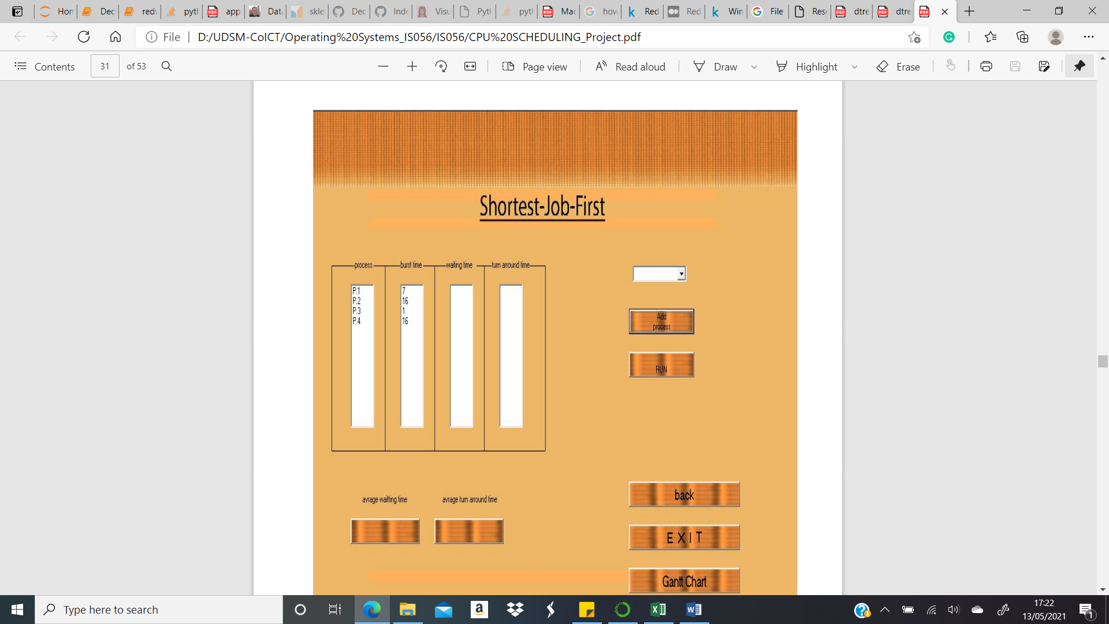

Due Date: Thursday, June 3rd, 2022